Increasing Grid Power Transmission Limits Using
Pv Statcom with New Controllers for Day and Night
JAJIMOGGALA SWAMI NAIDU,
Mr. A.V.SATYANARAYANA ,Mrs.C.Bharathi

1student, Dept.of Electrical and Electronics Engineering,GONNA INSTITUTE OF INFORMATION TECHNOLOGY&SCIENCES
(Approved by AICTE,New Delhi Affiliated to JNTU,KAKINADA)
Gonnavanipalem,Paravada(mandal)
VISAKHAPATNAM -530046
2Assistant Professor, Dept.of Electrical and Electronics Engineering,GONNA INSTITUTE OF INFORMATION TECHNOLOGY&SCIENCES
(Approved by AICTE,New Delhi Affiliated to JNTU,KAKINADA)
Gonnavanipalem,Paravada(mandal)
VISAKHAPATNAM -530046
3Associate Professor, Dept.of Electrical and Electronics Engineering,GONNA INSTITUTE OF INFORMATION TECHNOLOGY&SCIENCES
(Approved by AICTE,New Delhi Affiliated to JNTU,KAKINADA)
Gonnavanipalem,Paravada(mandal)
VISAKHAPATNAM -530046

Abstract: This paper presents a novel concept of utilizing aphotovoltaic (PV) solar farm inverter as STATCOM, called PV-STATCOM, for improving stable power transfer limits of the interconnected transmission system. The entire inverter rating of the PV solar farm, which remains dormant during nighttime, is utilized with voltage and damping controls to enhance stable power transmission limits. During daytime, the inverter capacity left after real power production is used to accomplish the aforementioned objective. Transient stability studies are conducted on a realistic single machine infinite bus power system having a midpoint located PV-STATCOM using EMTDC/PSCAD simulation software. The PV-STATCOM improves the stable transmission limits substantially in the night and in the day even while generating large amounts of real power. Power transfer increases are
also demonstrated in the same power system for: 1) two solar farms operating as PV-STATCOMs and 2) a solar farm as PV-STATCOM and an inverter-based wind farm with similar STATCOM controls. This novel utilization of a PV solar farm asset can thus improve power transmission limits which would have otherwise required expensive additional equipment, such as series/shunt capacitors or separate flexible ac transmission system controllers.

Keywords: Maximum Power Point Tracking (MPPT),Partial Shading, Photovoltaic (PV), Fuzzy Logic.
I. INTRODUCTION
Flexible AC transmission system (FACTS) controllers are being increasingly considered to increase the available power transfer limits/capacity(ATC) of existing transmission lines [1]–[4], globally. New research has been reported on the nighttime usage of a photovoltaic (PV) solar farm (when it is normally dormant) where a PV solar farm is utilized as a STATCOM–a FACTS controller, for performing voltage control, thereby improving system performance and increasing grid connectivity of neighboring wind farms [5],New voltage control has also been proposed on a PV solar farm to act as a STATCOM for improving the power transmission capacity [7]. Although, [8] and [9] have proposed voltage-control functionality with PV systems, none have utilized the PV system for power transfer limit improvement. A full converter-based wind turbine generatorhas recently been provided with FACTS capabilities for improved response during faults and fault ride through capabilities The photoelectric effect was first noted by French physicist Edmund Becquerel in 1839. He proposed that certain materials have property of producing small amounts of electric current when exposed to sunlight. In 1905, Albert Einstein explained the nature of light and the photoelectric effect which has become the basic principle for photovoltaic technology. In1954 the first photovoltaic module was built by Bell Laboratories. A photovoltaic system makes use of one or more solar panels to convertsolar energy into electricity. It consists of various components which include the photovoltaic modules, mechanical and electrical connections and mountings and means of modifying the electrical output.
II. STATIC SYNCHRONOUS COMPENSATOR(STATCOM)
The STATCOM is a solid-state-based power converter version of the SVC. Operating as a shunt-connected SVC, its capacitive or inductive output currents can be controlled independently from its terminal AC bus voltage. Because of the fast-switching characteristic of power converters, STATCOM provides much faster response as compared to the SVC. In addition, in the event of a rapid change in system voltage, the capacitor voltage does not change instantaneously; therefore, STATCOM effectively reacts for the desired responses. For example, if the system voltage drops for any reason, there is a tendency for STATCOM to inject capacitive power to support the dipped voltages. STATCOM is capable of high dynamic performance and its compensation does not depend on the common coupling voltage. Therefore, STATCOM is very effective during the power system disturbances. Moreover, much research confirms several advantages of STATCOM. These advantages compared to other shunt compensators include:
- Size, weight, and cost reduction
- Equality of lagging and leading output
- Precise and continuous reactive power control with fast response
- Possible active harmonic filter capability

- PROPOSED WORK

This paper proposes novel voltage control, together with auxiliary damping control, for a grid-connected PV solar farm inverter to act as a STATCOM both during night and day for increasing transient stability and consequently the power transmission limit. This technology of utilizing a PV solar farm as a STATCOM is called PV-STATCOM. It utilizes the entire solar farm inverter capacity in the night and the remainder inverter capacity after real power generation during the day, both of which remain unused in conventional solar farm operation.
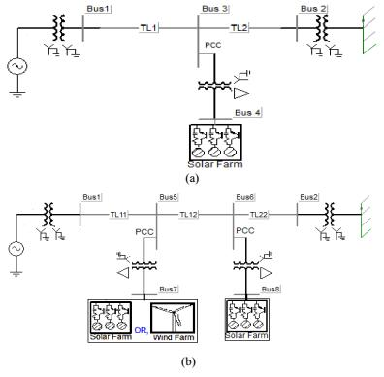

Fig. 1. Single line diagram of (a) Study system I with single solar farm (DG) and (b) Study System II with a solar farm (DG) and a solar/wind farm (DG).

The synchronous generator is represented by a detailed sixth order model and a DC1A-type exciter. The transmission-line segments TL1, TL2, TL11, TL12, and TL22, shown in Fig. 1, are represented by lumped pi-circuits. The PV solar DG, as shown in Fig. 2, is modeled as an equivalent voltage-source inverter along with a controlled current source as the dc source which follows the - characteristics of PV panels [11]

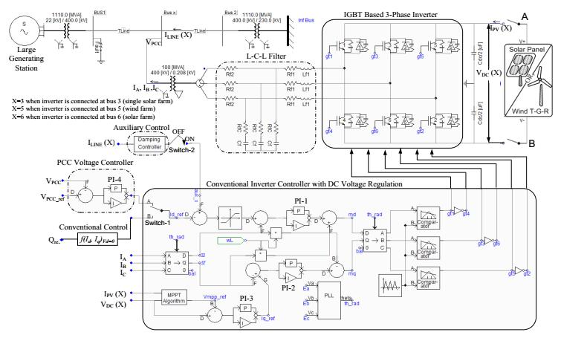

Fig. 2. Complete DG (solar/wind) system model with damping controller and PCC voltage control system.

The wind DG is likewise modeled as an equivalent voltagesource inverter. In the solar DG, dc power is provided by the solar panels, whereas in the full-converter-based wind DG, dc power comes out of a controlled AC–DC rectifier connected to the PMSG wind turbines, depicted as “wind Turbine-Generator-Rectifier (T-GR).” The dc power produced by each DG is fed into the dc bus of the corresponding inverter, as illustrated in Fig. 2.

A maximum power point tracking (MPPT) algorithm based on an incremental conductance algorithm [12] is used to operate the solar DGs at its maximum power point all of the time and is integrated with the inverter controller [11]. The wind DG is also assumed to operate at its maximum power point, since this proposed control utilizes only the inverter capacity left after the maximum power point operation of the solar DG and wind DG.

For PV-STATCOM operation during nighttime, the solar panels are disconnected from the inverter and a small amount of real power is drawn from the grid to charge the dc capacitor. The voltage-source inverter in each DG is composed of six insulated- gate bipolar transistors (IGBTs) and associated snubber circuits as shown in Fig.2. An appropriately large dc capacitor of size 200 Farad is selected to reduce the dc side ripple [13].

A novel auxiliary damping controller is added to the PV control system and shown in in Fig. 2.(b). This controller utilizes line current magnitude as the controlsignal. The output of this controller is added with the signal Id_ref.At first the base case generator operating power level is selected for performing the damping control design studies. This power level is considered equal to the transient stability limit of the system with the solar farm being disconnected at night. At this operating power level, if a three phase fault occurs at Bus 1, the generator power oscillations decay with a damping ratio of 5%. The solar farm is now connected and operated in the PV-STATCOM mode.

In this study, the solar DG is assumed to operate with its conventional reactive power controller the DG operates at near unity power factor. For the nighttime operation of solar DG, the DC sources (solar arrays) are disconnected and the solar DG inverter is connected to the grid using appropriate controllers, as described below. Power transmission limits are now determined for the following four cases. The maximum stable power output from the generator Pg is 731 MW when the solar DG is simply sitting idle during night and is disconnected from the network. This power flow level is chosen to be the base value against which the improvements in power flow with different proposed controllers are compared and illustrated. The damping controller utilizes the full rating of the DG inverter at night to provide controlled reactive power Qsolar and effectively damps the generator rotor mode oscillations. The voltages at generator bus Vg and at PCC bus Vrms(PCC). This reflects the losses in the inverter IGBT switches, transformer and filter resistances caused by the flow of real current from the grid into the solar farm inverter to charge the DC link capacitor and maintain its voltage constant while operating the PV inverter as STATCOM with the damping controller (or even with voltage controller). During nighttime, the reference DC Link voltage Vmpp_ref is chosen around the typical daytime rated maximum power point (MPP) voltage
IV.SIMULATION AND RESULTS
Simulink model
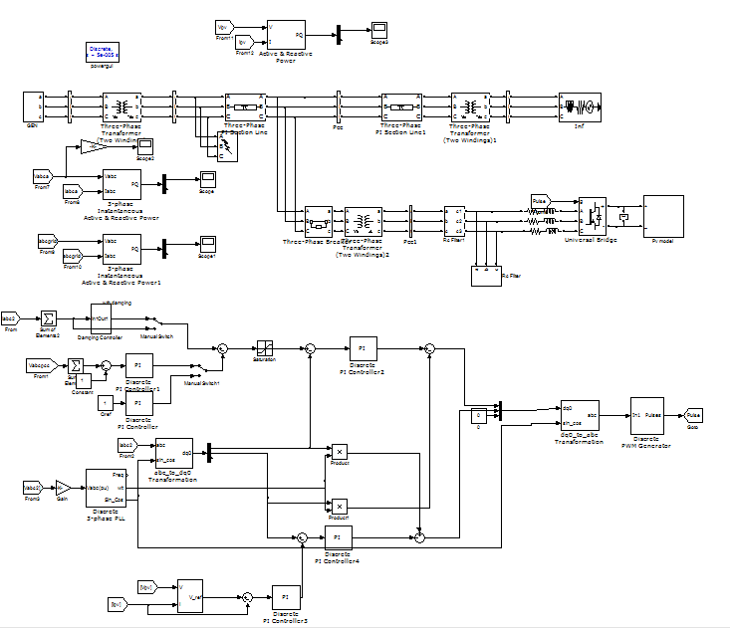
Fig: Proposed simulation diagram of PV-STATCOM

SIMULATION RESULTS:
Fig. 4. Maximum nighttime power transfer (731 MW) from the generator
when solar DG remains idle

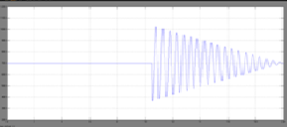
Fig4 (a): Real power at receiving end.
Fig4 (b) :Real power at sending end.

Fig4:Maximum nighttime power transfer (850 MW) from the generator with
solar DG using the damping controller

Fig4: Real power at receiving end.

Fig5:Maximum daytime power transfer (719 MW) from the generator with
solar DG generating 91-MW real power
Fig5 (a): Real power at receiving end

Fig4 (b): Real power at sending end

Maximum nighttime power transfer (899 MW) from the generator while the solar DG uses a damping controller with voltage control

5.CONCLUSION
Solar farms are idle during nights. A novel patent-pending control paradigm of PV solar farms is presented where they can operate during the night as a STATCOM with full inverter capacity and during the day with inverter capacity remaining after real power generation, for providing significant improvements in the power transfer limits of transmission systems [31], [32]. This new control of PV solar system as STATCOM is called PV-STATCOM.
The effectiveness of the proposed controls is demonstrated on two study SMIB systems: System I has one 100-MW PV-STATCOM and System II has one 100-MW PV-STATCOM and another 100-MW PV-STATCOM or 100-MW wind farm controlled as STATCOM. Three different types of STATCOM controls are proposed for the PV solar DG and inverter-based wind DG. These are pure voltage control, pure damping control, and a combination of voltage control and damping control.
The following conclusions are made: 1) In study system I, the power transfer can be increased by 168 MW during nighttime and by 142 MW in daytime even when the solar DG is generating a high amount of real power. 2) In Study System II, the transmission capacity in the night can be increased substantially by 229 MW if no DG is producing real power. During nighttime and daytime, the power transfer can be increased substantially by 200 MW, even when the DGs are generating high real power.
This study thus makes a strong case for relaxing the present grid codes to allow selected inverter-based renewable generators (solar and wind) to exercise damping control, thereby increasing much needed power transmission capability. Such novel controls on PV solar DGs (and inverter-based wind DGs) will potentially reduce the need for investments in additional expensive devices, such as series/shunt capacitors and FACTS. The PV-STATCOM operation opens up a new opportunity for PV solar DGs to earn revenues in the nighttime and daytime in addition to that from the sale of real power during the day. This will, of course, require appropriate agreements between the regulators, network utilities, solar farm developers, and inverter manufacturers.
REFERENCES
[1] R. M. Mathur and R. K. Varma, Thyristor-Based FACTS Controllers for Electrical Transmission Systems. Hoboken, NJ, USA: Wiley/IEEE, 2002.
[2] S. A. Rahman, R. K. Varma, and W. Litzenberger, “Bibliography of FACTS applications for grid integration of wind and PV solar power systems: 1995–2010, IEEE working group report,” presented at the IEEE Power Energy Soc. Gen. Meeting, Detroit, MI, USA, Jul. 2011.
[3] Y. Xiao, Y. H. Song, C.-C. Liu, and Y. Z. Sun, “Available transfer capability enhancement using FACTS devices,” IEEE Trans. Power Syst., vol. 18, no. 1, pp. 305–312, Feb. 2003.
[4] Cross Texas Transmission, Salt fork to gray project. 2014. [Online]. Available: http://www.crosstexas.com/SFWind.htm
[5] R. K. Varma, V. Khadkikar, and R. Seethapathy, “Nighttime application of PV solar farm as STATCOM to regulate grid voltage,” IEEE Trans. Energy Converse., vol. 24, no. 4, pp. 983–985, Dec. 2009.
[6] R. K. Varma and V. Khadkikar, “Utilization of solar farm inverter as STATCOM,” U.S. Provisional Patent, Sep. 15, 2009
. [7] R. K. Varma, S. A. Rahman, and R. Seethapathy, “Novel control of grid connected photovoltaic (PV) solar farm for improving transient stability and transmission limits both during night and day,” in Proc. World Energy Conf., Montreal, QC, Canada, 2010, pp. 1–6.
[8] R. A. Walling and K. Clark, “Grid support functions implemented in utility-scale PV systems,” in Proc. IEEE Power Energy Soc, Transm.Distrib. Conf. Expo., 2010, pp. 1–5.
[9] F. L. Albuquerque, A. J. Moraes, G. C. Guimaraes, S. M. R. Sanhueza, and A. R. Vaz, “Photovoltaic solar system connected to the electric power grid operating as active power generator and reactive power compensator,” Solar Energy, vol. 84, no. 7, pp. 1310–1317, Jul. 2010.
[10] A. Beekmann, J. Marques, E. Quitmann, and S. Wachtel, “Wind energy converters with FACTS Capabilities for optimized integration of wind power into trans. and dist. systems,” in Proc. CIGRE, Calgary, AB, Canada, 2009.
[11] S. A. Rahman and R. K. Varma, “PSCAD/EMTDC model of a 3-phase grid connected photovoltaic solar system,” in Proc. 43rd North Amer. Power Symp., Boston, MA, USA, 2011, pp. 1–5.
[12] K. H. Hussein, I. Muta, T. Hoshino, and M. Osakada, “Maximum photovoltaic power tracking: an algorithm for rapidly changing atmospheric conditions,” Proc. Inst. Elect. Eng., Gen., Transm. Distrib., vol. 142, no. 1, pp. 59–64, Jan. 1995.
[13] K. Chatterjee, B. G. Fernandes, and G. K. Dubey, “An instantaneous reactive volt–ampere compensator and harmonic suppressor system,” IEEE Trans. Power Electron., vol. 14, no. 2, pp. 381–392, Mar. 1999.

